Anticipated Disbursements / Entering Anticipated Disbursements

Anticipated Disbursements are payments that may be incurred during the course of the matter or an invoice to an outside party that you have yet to pay.

Anticipated Disbursements can be entered two different ways:
- Input Payment Voucher
- Cost Journal Input

In both cases, LawMaster will identify the disbursement as unpaid and will prevent you from Trust Transferring or receipting funds to the General Account until the disbursement has been paid.

Input Payment Voucher
When a voucher is entered into LawMaster, there is the option to set the payment date to in the future. Your firm can select a date in the future, or put the payment on hold. Either way, if it is assigned to a matter, it is unpaid until the payment is made and the cheque presented.

In the event that you need to reverse the disbursement, your Accounts team can cancel the unpaid voucher.

Cost Journal Input
To raise an Anticipated Disbursement, go to Transactions > Cost Journal Input or within the matter > Costs > Input Cost Journal.

My example below is an invoice received from George Smith for Barrister fees of $5,000.

Select the Transaction Type: Disbursements and then select the Expense Type from the disbursement codes. On the right of the screen, tick the box ‘Anticipated Disbursement?’.

When Anticipated Disbursements is selected, the Supplier field becomes available so that you can select the entity with whom you received the invoice.

In the Reference Number field, you can enter the invoice number, although this is not a mandatory field.

In the Narrative, enter the details of the invoice, then enter the total in the ‘Amount’ field and then select [Add Transaction].

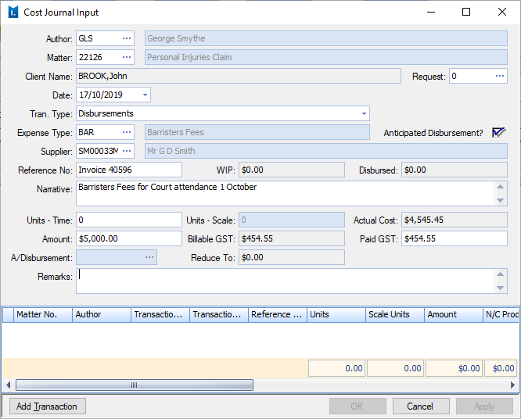

In the Costs Transactions, the disbursement will appear as a transaction and the word ‘Yes’ will be in the column ‘Anticipated/Held Cost’.

Billing an Anticipated Disbursement

When it comes time to bill this matter, you can bill it as normal and LawMaster will track the Anticipated Disbursement

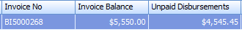

Receipting funds where an Anticipated Disbursement is on the matter.

When allocating a receipt to a matter that has an anticipated disbursement, on the allocation screen, [Unpaid Disbursement] will come into focus in to lower left corner, allowing you to review and pay the disbursement.

If you attempt to receipt to the General Account, LawMaster will prevent you with the following message:
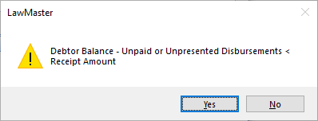

Paying an Anticipated Disbursement
There are two ways to pay an anticipated disbursement, via Input Payment Voucher or via the Costs screen.

It is important to note:
- If the payment is made from the General Account, the disbursement will become an unpaid disbursement in Debtors, until the cheque/EFT payment is reconciled in the bank account.

- If the payment is made from the Trust Account, the Debtor balance will be reduced from the amount owing by the client.

Paying an Anticipated Disbursement – Input Payment Voucher
When processing a payment from the Trust or General Account, LawMaster will recognise that the matter has anticipated disbursement on it and will prompt you to review the disbursements and link it to the anticipated disbursement.

If this payment is linked to the anticipated disbursement, select the transaction and press [OK].

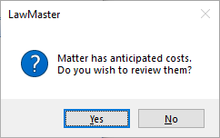

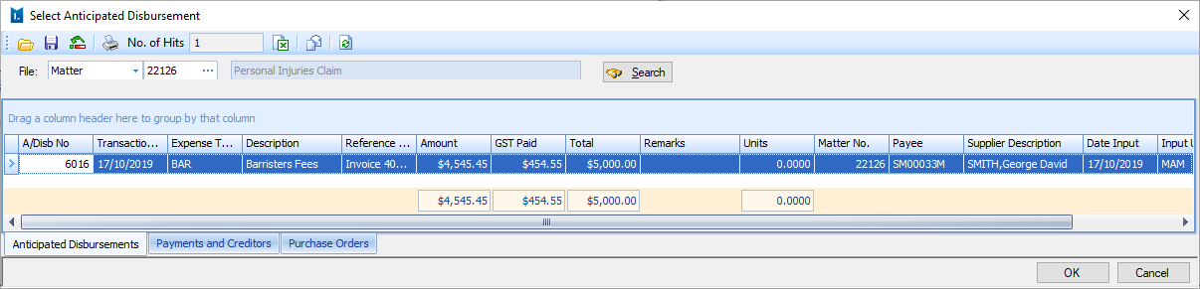

Paying an Anticipated Disbursement – Costs
In the Costs screen, change the Search: field to ‘Anticipated Costs and Cash’ to find the transaction.

Right click on the transaction and select ‘Pay transaction’.
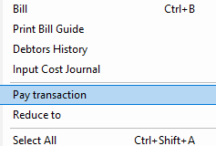

The ‘Pay Anticipated Disbursements’ screen will allow you to select the bank, method of payment and over-ride the amount to be paid.
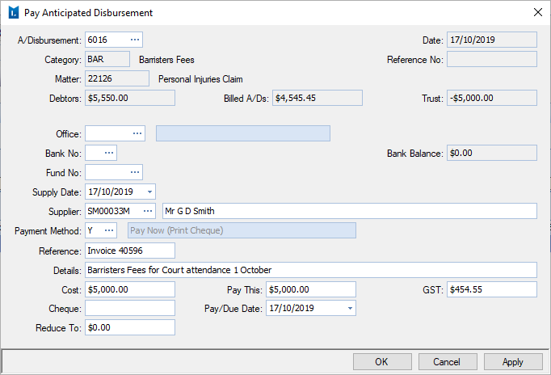

If the full amount of the Anticipated Disbursement is not being paid, LawMaster will write off the balance of the anticipated disbursement, unless the difference is entered into the ‘Reduce To’ field.
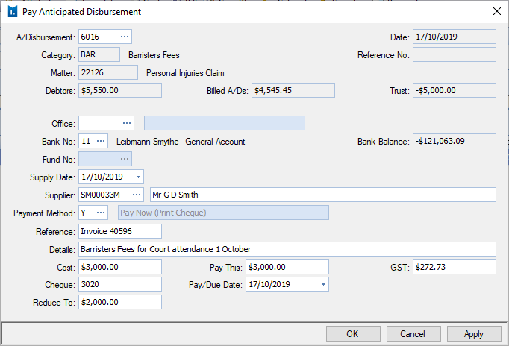

Part Pay an Anticipated Disbursement
If the full amount of the Anticipated Disbursement is not being paid at this point, you can advise LawMaster of the balance to remain on the invoice.

If paying the anticipated disbursement via Cost > Pay Transaction, enter the amount of the Costs and then enter the balance to remain on the ledger in the ‘Reduce To’ field.

If you part pay the anticipated disbursement via the Input Payment Voucher method, LawMaster will automatically calculate the difference and record this in the Reduce To field on the allocations screen.
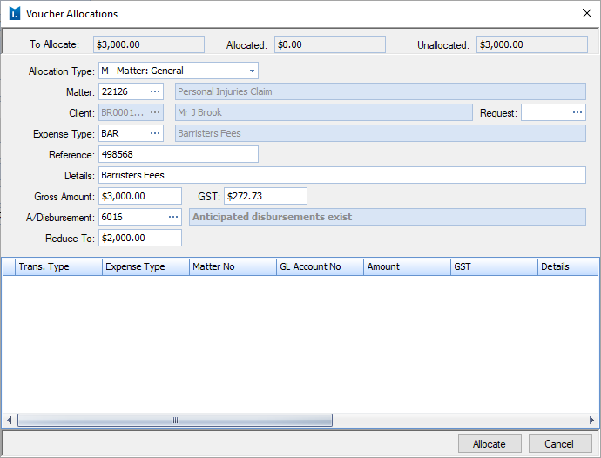

Reversing an Anticipated Disbursement
If an anticipated disbursement is to be reversed, go to the Costs screen and right click on the Anticipated Disbursement and select ‘Reduce To’

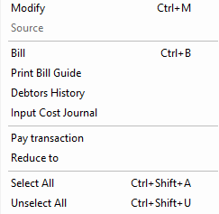

This will allow you to select the amount you are reducing the anticipated disbursement to or write it off to $0.00
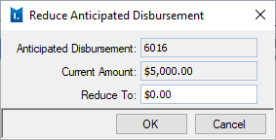

LawMaster will adjust the disbursement and Debtor Balance, if the anticipated disbursement has been paid.

Forgot to link a payment to an anticipated disbursement?
If you forget to link a payment to an anticipated disbursement, you will need to reverse the disbursement using the ‘Reduce To’ method.

If the payment was made through the General Account, you should bill this transaction and link the transaction to the existing bill.

Reporting on Anticipated Disbursements
To see a list of Anticipated Disbursements in LawMaster, go to Main Menu > Accounting > Enquiry > Anticipated Disbursements

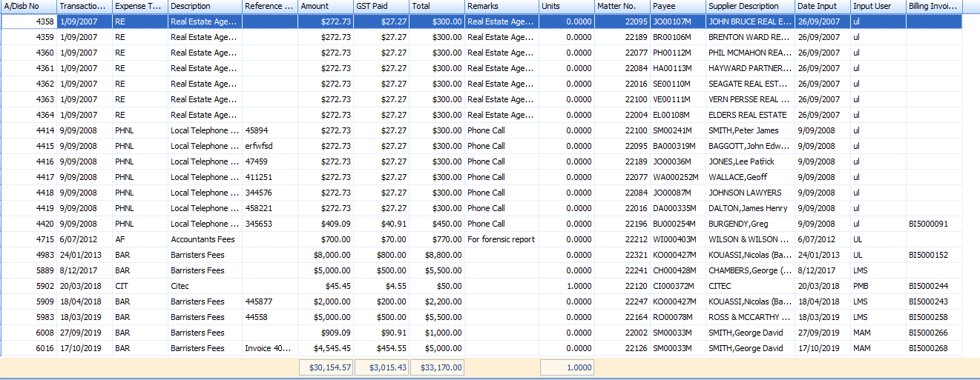

To see a list of matters that have a Trust Balance and Anticipated Disbursements, go to Main Menu > Accounting > Trust Accounting > Trust > List Possible Creditor Payments
