Windows Authentication
In order to use Windows authentication (Single Sign-On) to login to LawMaster, you must either:
• be hosting your own application server on a computer connected to your windows domain OR
• have an Microsoft AD FS server contactable from your user’s PCs.

To configure authentication options, from the Menubar select Parameters – Set Parameters – Miscellaneous – Authentication Options
1. The options dialog allows you to test windows integrated security (if your Application server is on your domain) or the connection to your AD FS server (from your current PC.)
2. Your AD FS server must be configured to authenticate LawMaster clients.
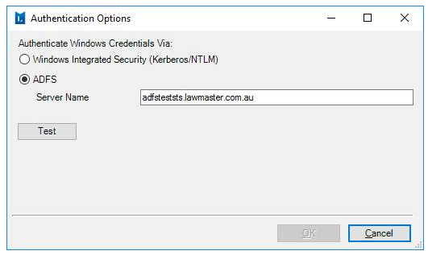
Regardless of which method you use to authenticate Windows credentials, you must then configure your resources with their windows domain accounts. The user@fulldomainname.com.au format is preferred, but domainname\user will continue to work for older Microsoft Operating Systems.

Instructions to Setup AD FS
1. Install and configure AD FS within your domain. Follow the links below for the help on the AD FS configuration.
2. Deployment guide https://docs.microsoft.com/en-us/windows-server/identity/ad-fs/ad-fs-deployment
3. Installation instructions https://docs.microsoft.com/en-us/windows-server/identity/ad-fs/deployment/install-the-ad-fs-role-service
4. Configuration instructions for AD FS (in general, not LawMaster specific) https://docs.microsoft.com/en-us/windows-server/identity/ad-fs/deployment/configure-a-federation-server
5. Non-Microsoft screenshots and tips that may help - http://samirvaidya.blogspot.com.au/2015/03/set-up-and-install-active-directory.html

Configure AD FS for LawMaster
The AD FS server then needs to be configured to accept connections from LawMaster applications. Follow the instructions below:
1. Open the AD FS Management application.
2. From the Actions panel on the right side, choose the ‘Add Relying Party Trust’ option.
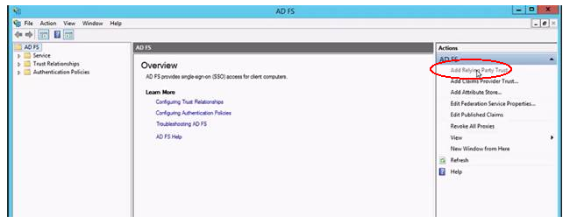
3. The system launches the Add Relying Party Trust Wizard. Click Start to initiate.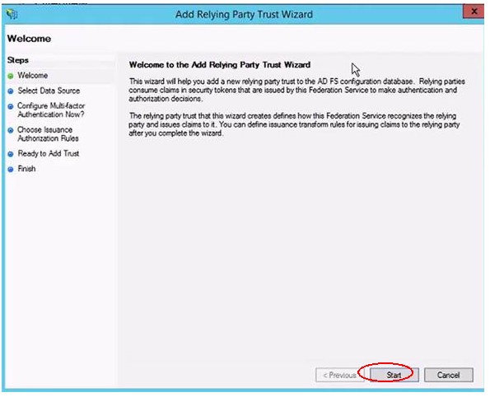
4. Select ‘Enter Data about the relying party manually’ and click Next.
5. Enter display name as ‘LawMaster’ and click Next.
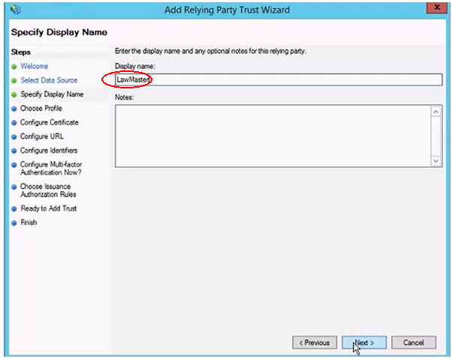
6. Choose the ‘AD FS profile’ option and click Next.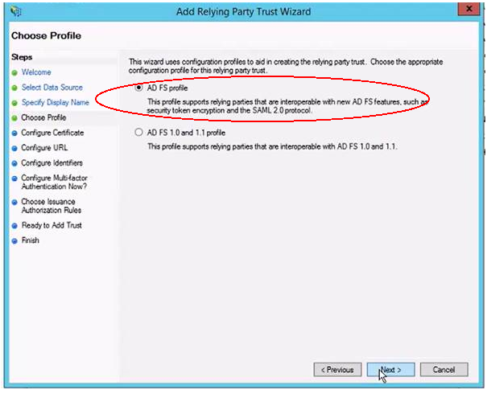
7. In the following screen, do not configure a certificate, and press Next.
8. Similarly, do not add support for WS-Federation or SAML 2 Web SS), and press Next.

9. Add an identifier of https://practicemanagementv10.lawmaster.com.au, and click Next.
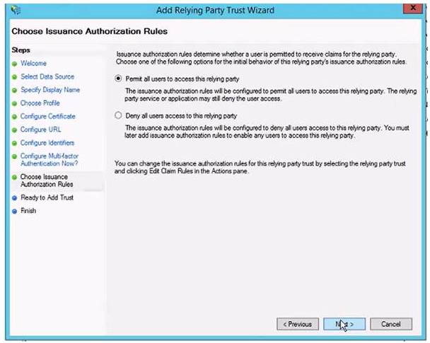

10. Choose not to configure multifactor authentication and click Next.
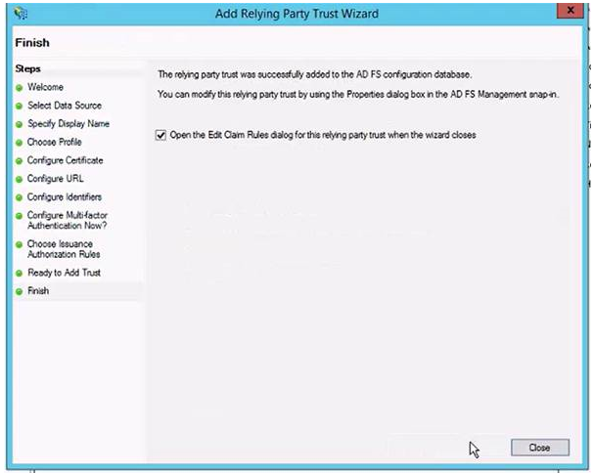

11. For authorisation rules, select to permit all users to access this relying party.
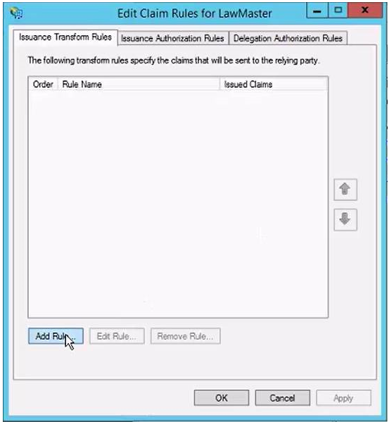
12. Do not set any advanced settings and click Next.

13. Select the ‘Open the Edit Claim Rules dialog for this relying party trust when the wizard closes’ option and then click Close.
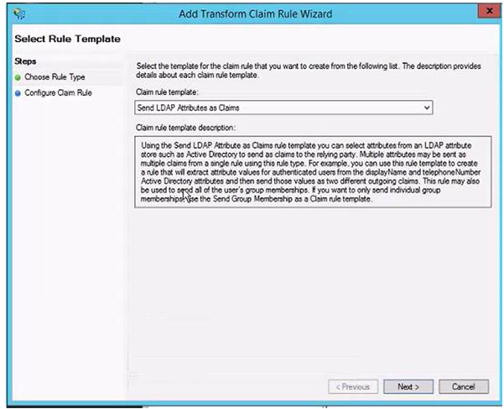

14. Add a claim rule by clicking the Add Rule button.
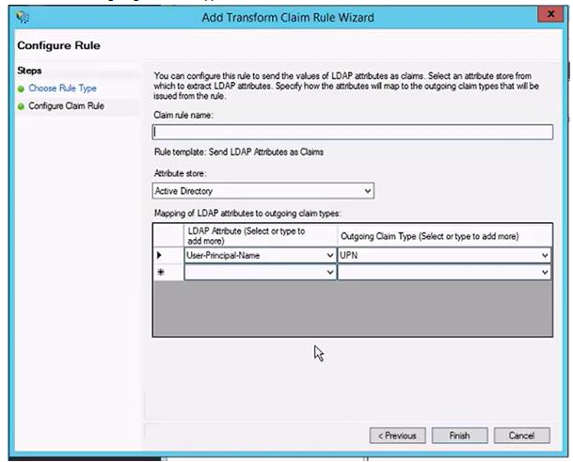

15. Choose claim rule template of ‘Send LDAP Attributes as Claims’ and click Next.
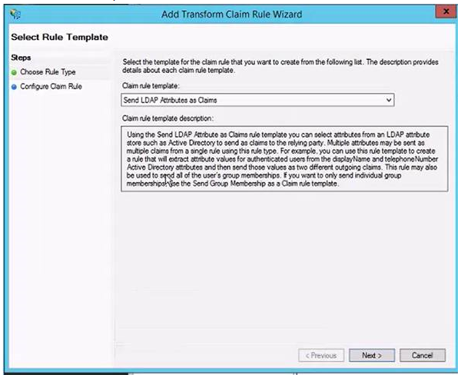

16. Enter a rule name as ‘LawMaster Claims’, and select ‘Active Directory’ as the Attribute Store. Choose to send ‘User-Principal-Name’ as an outgoing claim of type ‘UPN’, then click Finish.
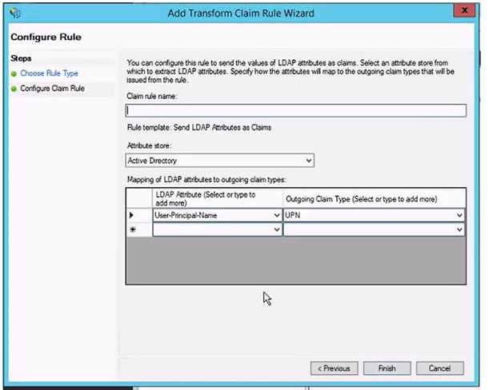

17. Back in the AD FS – Service – Endpoints configuration:
a. Enable the endpoint for adfs/services/trust/13/windowstransport
b. Enable the endpoint for /FederationMetaData/2007-06/FederationMetaData.xml
Refer to the notes below for internet connectivity.
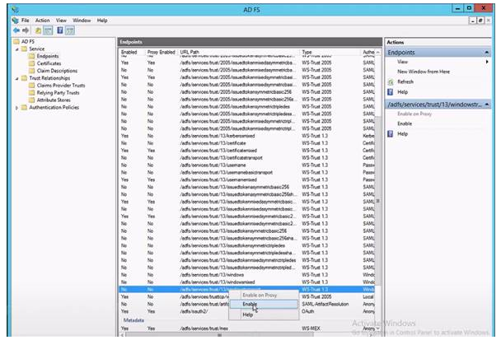
18. Restart the AD FS service if you were prompted to do so.

AD FS Meta Data Access
• Microsoft AD FS is designed to expose FederationMetaData.xml to the Internet.
• LawMaster’s application service will attempt to connect to that endpoint to obtain certificate signing information.
• By default AD FS will change the certificate it uses to sign claims every 12 months.
• If there is some reason you cannot or do not expose that endpoint to the application server, care must be taken to make sure the application service has the latest AD FS signing certificate details.
• You will receive a warning when using the authentication options test
• Performing that test (and pushing ok) will save the current AD FS certificate signing details with our application server.
• If no extra steps are taken, the system will work fine for a period of time until AD FS changes it’s signing certificate. (At which point all users will have to login with LawMaster credentials)
• If you wish to use AD FS in this way, we recommend disabling the automatic certificate rollover.
You can use this powershell command to do so:
Set-ADFSProperties -AutocertificateRollover $false

